Research Plan – Engineering / Software Project

**Title**

**Problem**

Is there a problem you are trying to solve?

**Background Information / Research**

Background information on your topic. Include your sources.

**Engineering Goal + Design Criteria**

Engineering Goal: What will you be building to solve the problem.  
Design Criteria: What does your prototype have to do to solve the problem. (this is what you test to)

**Materials**

What you need to do your project, make a list.

**Prototype Design + Build**

How will you design and build your prototype /s?

Are there any safety precautions with tools?

Draw what your prototype will look like.  
(a rough sketch is fine)

**Prototype Testing**

How will you test your prototype/s? (think back to your *engineering goal* and *design criteria*)   
What will you measure?

**Proposed Data Table**

What data are you collecting?  
Use the table below to show the data you will record.

|  |  |  |  |  |
| --- | --- | --- | --- | --- |
|  |  |  |  |  |
|  |  |  |  |  |
|  |  |  |  |  |
|  |  |  |  |  |
|  |  |  |  |  |
|  |  |  |  |  |
|  |  |  |  |  |

**Proposed Graph**

Proposed graph that you would make with title, x-axis labeled, y-axis labeled, x-axis units, and y-axis. Graph should have data plotted and look like an actual graph for your experiment.   
Use the data in your proposed data table to construct this graph.

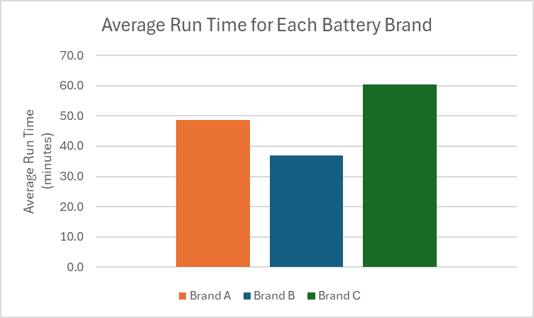

Example Graph

**Special Precautions**  
Check the box and fill out as applicable.

**Human Test Subjects**

1. Describe age range, gender, racial/ethnic composition
2. How will you recruit your participants? Or is it just you?
3. How will they test your prototype?
4. Risk assessment – Are there any risks to the participants (physical, psychological, time involvement, social, legal, etc.)? How will you minimize risk? Are there any benefits to the participants?
5. Protection of Privacy – Will identifiable information be collected? Will data be anonymous and how will anonymity be protected? It not anonymous, will data be confidential and how will confidentiality be safeguarded?
6. Where will data be stored? Who will have access to the data and what will happen to the data after the study?
7. Informed Consent Process – Describe how you will inform participants about the following four areas: 1) purpose of the study; 2) What they will be asked to do; 3) their participation is voluntary; and 4) they have the right to stop at any time. Where will informed consents be stored, by whom and for how long.