Research Plan – Science Project

**Title**

**Problem**

Is there a problem you are trying to solve?

**Background Information / Research**

Background information on your topic. Include your sources.

**Hypothesis**

Your prediction on what the outcome of your testing will be.

(Suggestion: If, then format. If something is done, then something will result.)  
(Suggestion 2: I think this will happen because…)

**Materials**

What you need to do your project, make a list.

**Proposed Data Table**

What data are you collecting?  
Use the table below to show the data you will record.

|  |  |  |  |  |
| --- | --- | --- | --- | --- |
|  |  |  |  |  |
|  |  |  |  |  |
|  |  |  |  |  |
|  |  |  |  |  |
|  |  |  |  |  |
|  |  |  |  |  |
|  |  |  |  |  |

**Proposed Graph**

Proposed graph that you would make with title, x-axis labeled, y-axis labeled, x-axis units, and y-axis. Graph should have data plotted and look like an actual graph for your experiment.   
Use the data in your proposed data table to construct this graph.

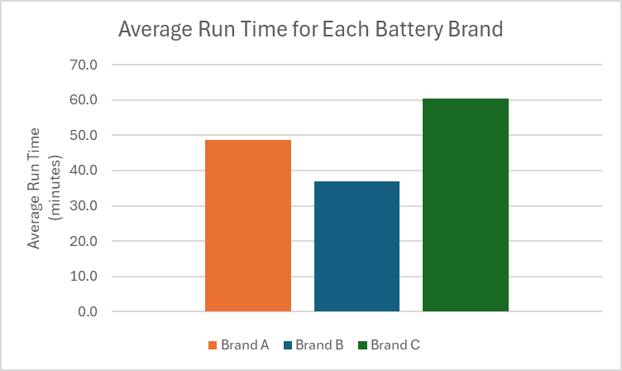

Example Graph

**Data Collection:** How you would collect data for the experiment and what you will use to measure it?

**Special Precautions**  
Check the box and fill out as applicable.

**Human Test Subjects**

1. Describe age range, gender, racial/ethnic composition
2. How will you recruit your participants?
3. Methodology – surveys, questionnaires, tests. Frequency and length of time involved per participant.
4. Risk assessment – Are there any risks to the participants (physical, psychological, time involvement, social, legal, etc.)? How will you minimize risk? Are there any benefits to the participants?
5. Protection of Privacy – Will identifiable information be collected? Will data be anonymous and how will anonymity be protected? It not anonymous, will data be confidential and how will confidentiality be safeguarded?
6. Where will data be stored? Who will have access to the data and what will happen to the data after the study?
7. Informed Consent Process – Describe how you will inform participants about the following four areas: 1) purpose of the study; 2) What they will be asked to do; 3) their participation is voluntary; and 4) they have the right to stop at any time. Where will informed consents be stored, by whom and for how long.

**PHBA (Bacteria) + Hazardous Chemicals or devices**

**Based on chart below:** Home BSL-1 BSL-2

PHBAs include but are not limited to:

* bacteria, viruses, viroids, prions, rickettsia, fungi, and parasites
* Human or animal fresh / frozen tissues, blood and body fluids
* rDNA

1. Location of experiment
2. Listing and source of materials
3. Safety equipment used (goggles, gloves, closed toe shoes)
4. Working Conditions (BSL cabinet, fume hood, etc)
5. Disposal of test samples

**Vertebrate Animals**

1. Location of the testing
2. Describe the living conditions, cleaning and feeding schedule
3. Describe the life after experimentation is complete
4. Measurements and data collection with the animals
5. Methods used to minimize discomfort, distress, pain and injury to the animals.
6. Describe animal numbers, species, strain, sex, age, source of animals
7. Human or animal fresh / frozen tissues, blood and body fluids
8. Potential alternatives to vertebrate animal use and justification for use