Research Plan – Science Project
Title

Rationale (Problem)
A few sentences explaining why you are doing the research and background information on it.
- Is there a problem you are trying to solve?
- Why is it interesting to you?
- Why is it important or should others care about the research?

Variables
Independent (what we are changing and testing)
Dependent (what we are measuring)

Controls (what we are keeping the same for each trial)

Hypothesis/es
Your prediction on what the outcome of your testing will be.
(Suggestion: If, then format. If something is done, then something will result.)

Materials
What do you need to do your project.

Procedure
Sequentially numbered steps that cover the procedure from beginning to end. The steps should be detailed enough for someone else to be able to replicate the study from your steps. This section is divided into multiple sections.
Experimentation:
What you will be doing step by step in your experiment.

Measurements:
What are you going to measure and how?
What tools are needed?
Where are you recording and storing data.

Data Analysis: Include a description of the techniques or statistical tests that will be employed to analyze the results of the experimentation.

Bibliography
Sources on your topic.

Special Precautions
Check the box and fill out as applicable.

☐Human Test Subjects
- Describe age range, gender, racial/ethnic composition
- How will you recruit your participants?
- Methodology – surveys, questionnaires, tests. Frequency and length of time involved per participant.
- Risk assessment – Are there any risks to the participants (physical, psychological, time involvement, social, legal, etc.)? How will you minimize risk? Are there any benefits to the participants?
- Protection of Privacy – Will identifiable information be collected? Will data be anonymous and how will anonymity be protected? It not anonymous, will data be confidential and how will confidentiality be safeguarded?
- Where will data be stored? Who will have access to the data and what will happen to the data after the study?
- Informed Consent Process – Describe how you will inform participants about the following four areas: 1) purpose of the study; 2) What they will be asked to do; 3) their participation is voluntary; and 4) they have the right to stop at any time. Where will informed consents be stored, by whom and for how long.

☐ PHBA (Bacteria) + Hazardous Chemicals or devices
Based on chart below: ☐Home ☐BSL-1 ☐BSL-2
- bacteria, viruses, viroids, rickettsia, fungi, and parasites
- Human or animal fresh / frozen tissues, blood and body fluids
- rDNA
- Location of experiment
- Listing and source of materials
- Safety equipment used (goggles, gloves, closed toe shoes)
- Working Conditions (BSL cabinet, fume hood, etc)
- Disposal of test samples

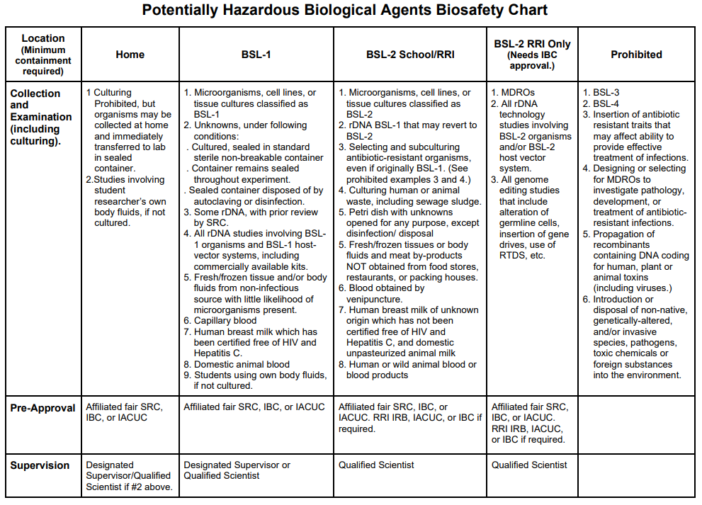
☐ Vertebrate Animals
- Location of the testing
- Describe the living conditions, cleaning and feeding schedule
- Describe the life after experimentation is complete
- Measurements and data collection with the animals
- Methods used to minimize discomfort, distress, pain and injury to the animals.
- Describe animal numbers, species, strain, sex, age, source of animals
- Human or animal fresh / frozen tissues, blood and body fluids
- Potential alternatives to vertebrate animal use and justification for use

